Updated version
No. | Date | Version | Change Summary | Author
1 | 03/04/12 | 1.0 | First Issue | TamDo

Table of contents
1. Purpose 3
2. Usecase Diagram 3
3. High Level Requirements Table 7
4. Constraints (Technical & Business) Table 9
5. Quality Attributes Table 10
6. Task 1 11
7. Task 2 12

Purpose
This document provides the information about the high level functional requirements, constraints (technical & business), and quality attributes that are important to the stakeholders of the system.

Usecase Diagram
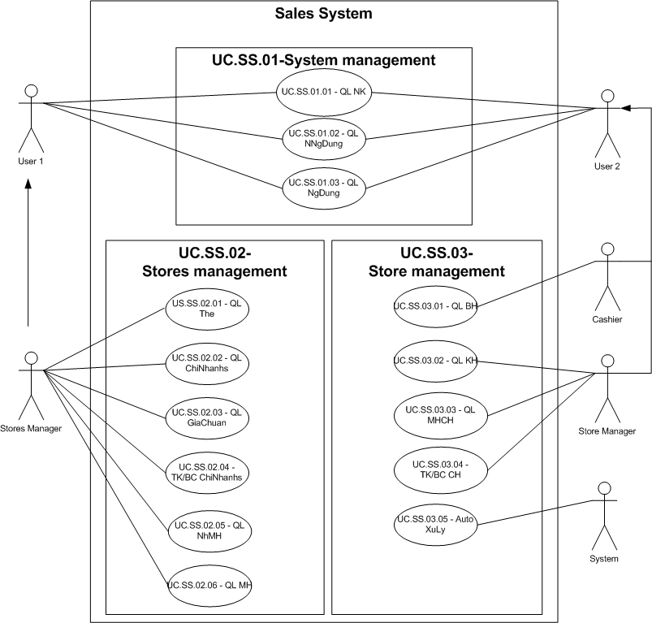

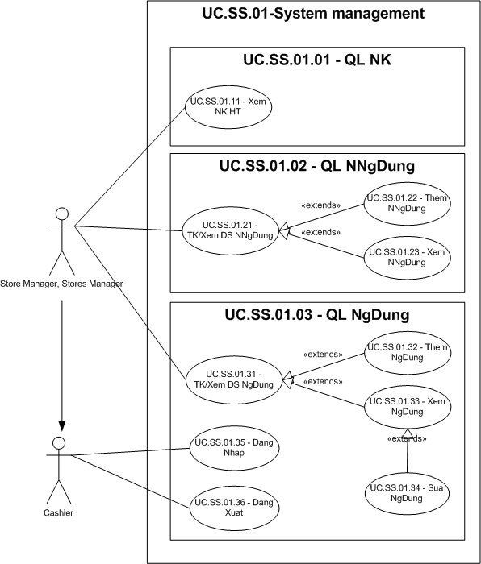
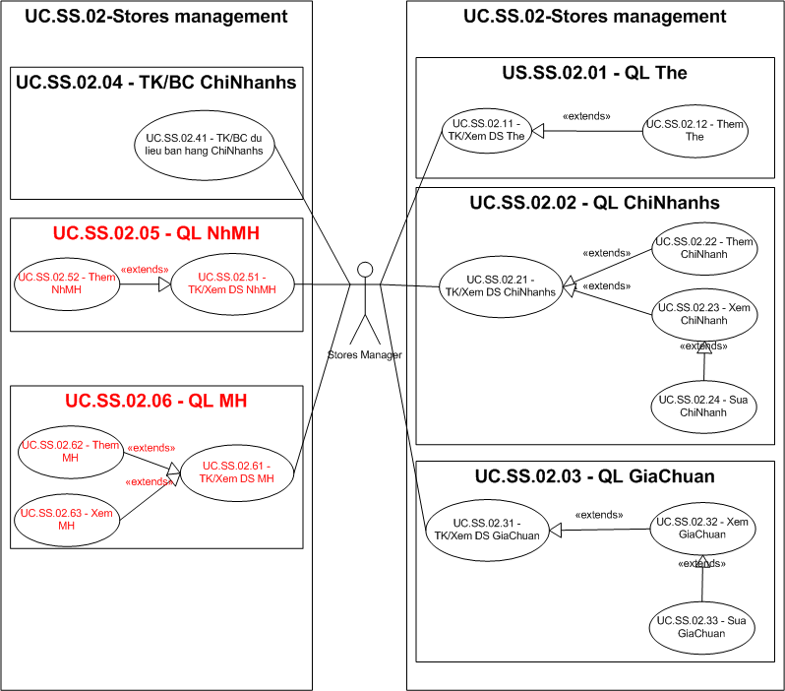
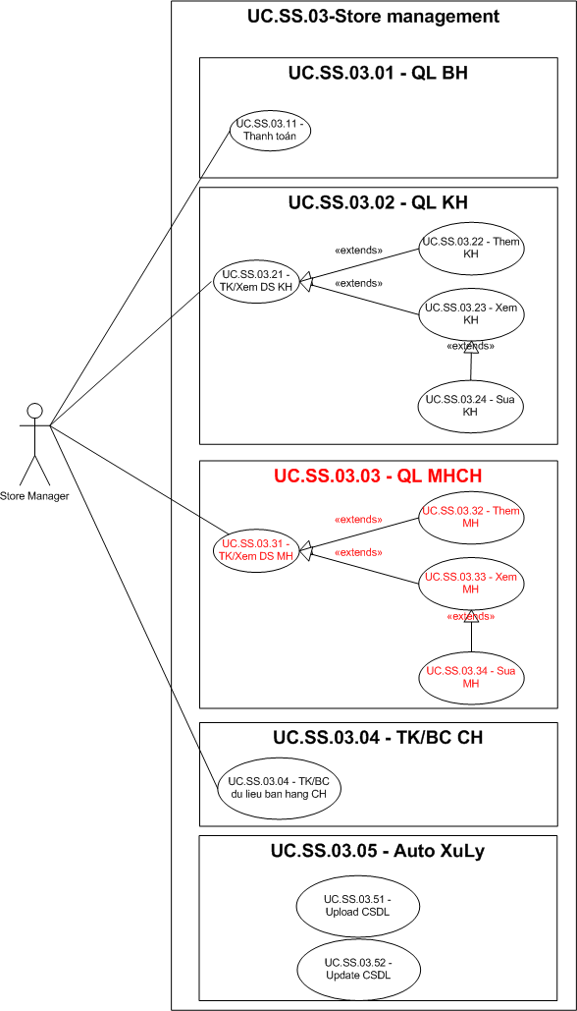

High Level Requirements Table
Module | ID | Functional | Description | Usecase
System Management | Quản lý nhật ký (FT.SS.01.01)
System Management | FC.SS.01.11 | Xem NK HT | Xem nhật ký hệ thống
System Management | Quản lý nhóm người dùng (FT.SS.01.02)
System Management | FC.SS.01.21 | TK/Xem DS NNgDung | Tìm kiếm/Xem danh sách nhóm người dùng
System Management | FC.SS.01.22 | Them NNgDung | Thêm nhóm người dùng
System Management | FC.SS.01.23 | Xem NNgDung | Xem nhóm người dùng
System Management | Quản lý người dùng (FT.SS.01.03)
System Management | FC.SS.01.31 | TK/Xem DS NgDung | Tìm kiếm/Xem danh sách người dùng
System Management | FC.SS.01.32 | Them NgDung | Thêm người dùng
System Management | FC.SS.01.33 | Xem NgDung | Xem thông tin người dùng
System Management | FC.SS.01.34 | Sua NgDung | Cập nhật thông tin người dùng
System Management | FC.SS.01.35 | Dang Nhap
System Management | FC.SS.01.36 | Dang xuat
Stores Management | Quản lý thẻ (FT.SS.02.01)
Stores Management | FC.SS.02.11 | TK/Xem DS The | Tìm kiếm/Xem danh sách thẻ
Stores Management | FC.SS.02.12 | Them The | Thêm 1 mã thẻ
Stores Management | Quán lỷ các cửa hàng (FT.SS.02.02)
Stores Management | FC.SS.02.21 | TK/Xem DS ChiNhanhs | Tìm kiếm/Xem danh sách các cửa hàng
Stores Management | FC.SS.02.22 | Them ChiNhanh | Thêm 1 cửa hàng
Stores Management | FC.SS.02.23 | Xem ChiNhanh | Xem thông tin 1 cửa hàng
Stores Management | FC.SS.02.24 | Sua ChiNhanh | Cập nhật thông tin 1 cửa hàng
Stores Management | Quản lý giá tiêu chuẩn cho các cửa hàng (FT.SS.02.03)
Stores Management | FC.SS.02.31 | TK/Xem DS GiaChuan | Tìm kiếm/Xem danh sách giá tiêu chuẩn cho các cửa hàng
Stores Management | FC.SS.02.32 | Xem GiaChuan
Stores Management | FC.SS.02.33 | Sua GiaChuan
Stores Management | Thống kê/Báo cáo dữ liệu bán hàng của các cửa hàng (FT.SS.02.04)
Stores Management | FC.SS.02.41 | TK/BC du lieu ban hang ChiNhanhs
Stores Management | Quản lý nhóm mặt hàng (FT.SS.02.05)
Stores Management | FC.SS.02.51 | TK/Xem DS NhMH
Stores Management | FC.SS.02.52 | Them NhMH
Stores Management | Quản lý mặt hàng (FT.SS.02.06)
Stores Management | FC.SS.02.61 | TK/Xem DS MH
Stores Management | FC.SS.02.62 | Them MH
Stores Management | FC.SS.02.63 | Xem MH
Store Management | Quản lý bán hàng (FT.SS.03.01)
Store Management | FC.SS.03.11 | Thanh Toan
Store Management | Quản lý khách hàng (FT.SS.03.02)
Store Management | FC.SS.03.21 | TK/Xem DS KH
Store Management | FC.SS.03.22 | Them KH
Store Management | FC.SS.03.23 | Xem KH
Store Management | FC.SS.03.24 | Sua KH
Store Management | Quản lý mặt hàng tại cửa hàng (FT.SS.03.03)
Store Management | FC.SS.03.31 | TK/Xem DS MH
Store Management | FC.SS.03.32 | Them MH
Store Management | FC.SS.03.33 | Xem MH
Store Management | FC.SS.03.34 | Sua MH
Store Management | Thống kê/Báo cáo tại cửa hàng (FT.SS.03.04)
Store Management | FC.SS.03.41 | TK/BC du lieu ban hang trong CH
Store Management | Tự động thực thi xử lý các hoạt động ngày hôm trước, và bắt đầu ngày sau (FT.SS.03.05)
Store Management | FC.SS.03.51 | Upload CSDL
Store Management | FC.SS.03.52 | Update CSDL

Constraints (Technical & Business) Table
Type | ID | Constraint | Description
Technical | TC.SS.01 | Client – Server
Technical | TC.SS.02 | Both the Client and the Server are equipped with a Database | Both of them can be accessed during the sales operation
Technical | TC.SS.03 | Use SQL Server Database
Business | BC.SS.01 | The point award rate
Business | BC.SS.02 | Point are recorded in the system, and not on the point card
Business | BC.SS.03 | The awarded points become valid for use the following day | The awarded points can be used by the member who accrued the points in place of cash when making a purchase. Points can be used in all stores.
Business | BC.SS.04 | The number of points used is immediately subtracted from the number of points accrued by the member
Business | BC.SS.05 | For each product, its standard price, common to all stores
Business | BC.SS.06 | The system executes a batch process which post-processes the sales operations from previous day, and prepares for the daily sales operations.

Quality Attributes Table
Quality Attribute | Description
Availability
Performance

Task 1
- Functional usecase
- Availability Quality Attribute scenarios
Portion of scenario | Possible value
Soure | Internal
Stimulate | System failure (No response from the system)
Artifact | System
Environment | System operating environment (runtime)  Each client and server has local database.  Support internet
Response | Detect a network or server crack, perform provide failover, and recover fully.
Response measure | Operate system on local database  Unavailability time interval

- Performance Quality Attribute scenarios
Portion of scenario | Possible value
Soure | Users
Stimulate | Initiate transactions
Artifact | System
Environment | System operating environment (runtime)  Support internet
Response | Transactions are processed  Transactions data stored into local database.
Response measure | Average latency immediately (within 5s)

Task 2

